Torsion of Circular Shafts

Torque is a moment that tends to twist a member about its longitudinal axis. Torsional deformation is a concern in the design of drive shafts used in machinery. The effect of torque applied on a shaft can be illustrated by taking a shaft made of rubber. Along the length of the shaft, straight lines are marked and along the circumference, circles are engraved. Also note the radial lines engraved on the cross section.
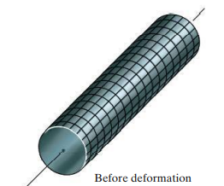 | 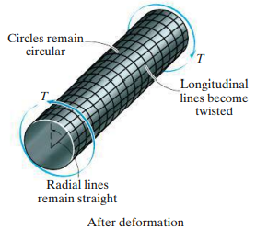
When the torque is applied, the circular and longitudinal grid lines marked on the shaft will distort as shown. The circles will remain circles and each longitudinal grid line deforms in to a helix that intersects the circles at equal angles. Also, the cross sections at the end of the shaft will remain flat (they do not warp or bulge in or out) and the radial lines remain straight. From these observations it can be assumed that if the angle of twist is small, the length of the shaft and its radius will remain unchanged.
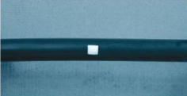 | 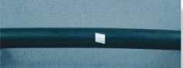
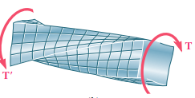 | Torsion of non circular shafts

If the shaft is fixed at one end and a torque T is applied at the other end, the plane OABC distorts to OA’BC. A radial line located at cross section at a distance $x$ from the fixed end will rotate through an angle $θ(x)$, defined as angle of twist. It depends on the distance $x.$ | 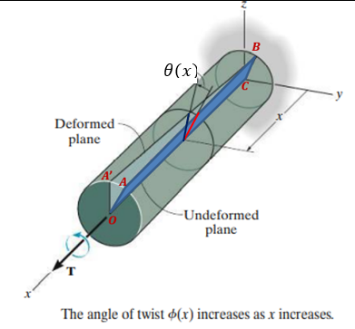

Let us take a small element located at a radial distance $ρ$ from the axis of the shaft. Due to the deformation, the front and rear faces of the element will undergo a rotation- the back face by $θ(x)$, and the front face by $θ\left(x\right)+Δθ$. Due to this difference in rotations $Δθ,$ the element is subjected to a shear strain.  $$γ=\frac{π}{2}-θ'$$  $$BD=γ Δx=ρΔθ$$  $$γ=ρ\frac{Δθ}{Δx}$$  As $Δx→0, γ=ρ\frac{dθ}{dx}$  Since $Δθ$ and $∆x$ are the same for any element at any radius $ρ$, $\frac{dθ}{dx}$ will be constant (angle of twist per unit length). Hence, the shear strain depends on the radius.  $$γ=ρ\frac{θ}{L}→ γ_{max}=R\frac{θ}{L} → γ=ρ\frac{γ_{max}}{R}$$ | 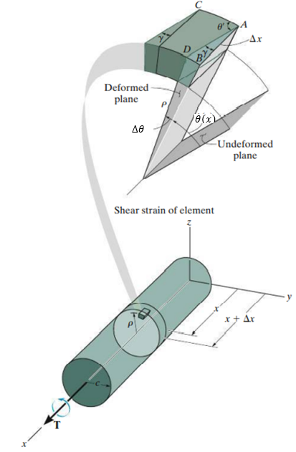
That is, the shear strain is maximum at the surface.
$$τ_{max}=Gγ_{max}=R\frac{Gθ}{L}$$
$$τ=Gγ=Gρ\left(\frac{γ_{max}}{R}\right)=Gγ_{max}\left(\frac{ρ}{R}\right)=τ_{max} \left(\frac{ρ}{R}\right)$$

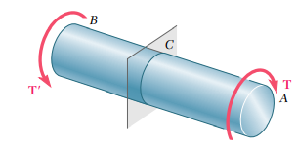 | 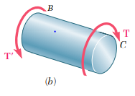 | 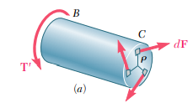
When a torque T is applied to one end of the shaft, at any section in between an equal torque in opposite direction will be developed. This torque is the moment of the force due to the shear stress acting over the cross section. If $τ$ is the shear stress acting on the cross section at radius $ρ.$ Consider a small elementary area $dA$. The elemental force acting over this area,
$dF=τ dA ≫≫ dF=τ_{max} \left(\frac{ρ}{R}\right)dA ≫≫dF=\left(\frac{τ_{max}}{R}\right)$ $ρ dA$
Moment of this force about the axis of the shaft, $dM=dF ×ρ=\left(\frac{τ_{max}}{R}\right)$ $ρ dA×ρ$
Total moment of all such elementary forces, $M=\int{\left(\frac{τ_{max}}{R}\right)ρ^{2} dA=\left(\frac{τ_{max}}{R}\right)\int{ρ^{2} dA}}$
For equilibrium, $T-M=0$
$$T=\left(\frac{τ_{max}}{R}\right)\int{ρ^{2} dA}=\left(\frac{τ_{max}}{R}\right) J$$
Where $J=\int{ρ^{2} dA}$, the polar moment of inertia of the cross section.
$$τ_{max}=\frac{T}{J}R$$
$$∴shear stress at any radius, τ=τ_{max} \left(\frac{ρ}{R}\right)=\frac{T}{J}ρ$$
The variation of shear stress along the radius of the shaft is shown | 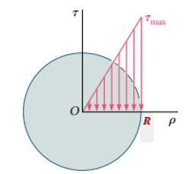
$$τ_{max}=R\frac{Gθ}{L} ≪≫ τ_{max}=\frac{T}{J}R$$
$$\frac{T}{J}=\frac{τ_{max}}{R}=\frac{Gθ}{L}$$
This is known as Torsion formula for the circular shaft.

If an element of material on the cross section is isolated, then due to complementary property of shear, equal shear stress must also act on four of its adjacent faces. Thus, torsion develops shear stress not only on the cross-sectional plane but along the axial plane also. |  | 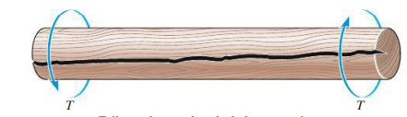
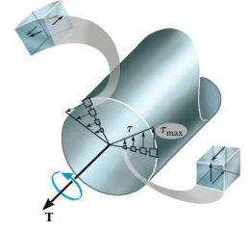 | 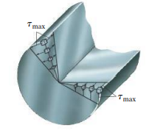

#Example 1  A hollow cylindrical steel shaft is $1.5 m$ long and has inner and outer diameter $40$ and $60 mm$ respectively. What is the maximum torque it can carry if the permissible shear stress is $120 MPa$? What is the corresponding angle of twist if the shear modulus is $70 GPa$? |  | 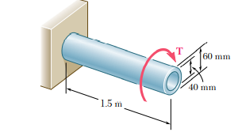
Length of the shaft, $L=1.5 m$  Inner diameter, $d=0.04 m$  Outer diameter, $D=0.06 m$  Permissible shear stress, $τ_{max}=120 MPa$  Shear modulus, $G=70×{10}^{9} Pa$ | Polar moment of inertia of the cross section of the shaft, $J=\frac{π}{32}\left(D^{4}-d^{4}\right)$  $$=\frac{π}{32}\left({0.6}^{4}-{0.4}^{4}\right)=1.021×{10}^{-6}m^{4}$$
From the Torsion formula,  $$\frac{T}{J}=\frac{τ_{max}}{R}=\frac{Gθ}{L}$$  $$T=\frac{τ_{max}}{R}J=\frac{120×{10}^{6}×1.021×{10}^{-6}}{0.03}$$  $$=4.08 kN.m$$ | $$θ=\frac{TL}{GJ}=\frac{4.08×{10}^{3}×1.5}{70×{10}^{9}×1.021×{10}^{-6}}=0.0856 rad=4.9°$$

#Example 2
A solid steel shaft in a rolling mill transmits $20 kW$ of power at $120 rpm$. Determine the smallest safe diameter of the shaft if the shear stress is not to exceed $40 MPa$ and the angle of twist is limited to $6°$ in a length of $3m$. Use $G=83 GPa$
Power, $P=\frac{2πNT}{60}$  Torque,$T=\frac{60P}{2πN}=\frac{60×20×{10}^{3}}{2π×120}=1591.6 Nm$  To satisfy the strength requirement,  $$\frac{T}{J}=\frac{τ_{max}}{R}$$  $$T=\frac{τ_{max}×\left(\frac{πd^{4}}{32}\right)}{\left(\frac{d}{2}\right)}=\frac{πd^{3}τ_{max}}{16}$$  $$d=\sqrt[3]{\frac{16×1591.6}{π×40×{10}^{6}}} =0.0587 m =58.7 mm$$ | To satisfy the stiffness requirement,  $\frac{T}{J}=\frac{Gθ}{L}$ $(θ=6°=6×\frac{π}{180}=0.105 rad)$  $$\frac{1591.6}{\frac{πd^{4}}{32}}=\frac{83×{10}^{9}×0.105}{3}$$  $$d=\sqrt[4]{\frac{1591.6×32×3}{π×83×{10}^{9}×0.105}}=0.0486 m$$  $$=48.6 mm$$  To satisfy both the conditions, the diameter of the shaft should be $58.7 mm$

#Example 3  Shaft $BC$ is hollow with inner and out diameters of $90 mm$ and $120 mm$, respectively. Shafts $AB$and $CD$ are solid and of diameter $d$. For the loading shown, determine (a) the maximum and minimum shearing stress in shaft $BC$ (b) the required diameter $d$ of shafts $AB$and $CD$ if the allowable shearing stress in these shafts is $65 MPa$ | 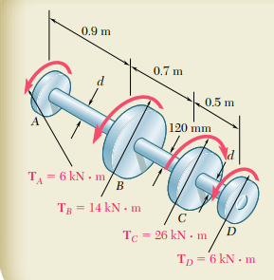
Taking a section of the shaft $AB$ from the left end and consider the free-body diagram,  $$T_{AB}-6 kN.m=0 → T_{AB}=6 kN.m$$ | 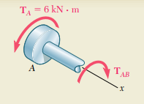
Now take a section between $B$ and $C$.  $$T_{BC}-6 kN.m-14 kN.m=0$$  $$T_{BC}=20 kN.m$$  For the hollow shaft $BC$,  $J_{BC}=\frac{π}{32}\left({0.12}^{4}-{0.09}^{4}\right)=13.92×{10}^{-6} m^{4}$ | 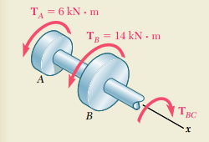

Maximum shear stress on $BC$,
$$τ_{BC max}=\frac{T_{BC}}{J_{BC}}×R_{BC}=\frac{20×{10}^{3}N.m}{13.92×{10}^{-6} m^{4}}×0.06m=86.2×{10}^{6}Pa$$
$$τ_{BC min}=\frac{T_{BC}}{J_{BC}}×r_{BC}=\frac{20×{10}^{3}N.m}{13.92×{10}^{-6} m^{4}}×0.045m=64.7×{10}^{6}Pa$$
Shafts $AB$ and $CD$
$$τ_{AB max}=\frac{T_{AB}}{J_{AB}}×R_{AB}→→→65×{10}^{6}Pa=\frac{6 kNm}{\frac{π}{32}\left(d^{4}\right)}×\left(\frac{d}{2}\right)$$
$$d=77.8×{10}^{-3}m$$
Strain Energy in Torsion
If the material follows Hooke’s law, the Torque-rotation ($T-θ$) diagram will be a straight line.
The strain energy, $U=\frac{1}{2}Tθ$
From the shear stress- shear strain diagram, the strain energy density in Torsion,
$$u=\frac{1}{2}τγ=\frac{τ^{2}}{2G}$$

Exercise
- The pipe shown in figure has an inner diameter of $80 mm$ and an outer diameter of $100 mm.$ If its end is tightened against the support at $A$ using a wrench at $B$, determine the shear stress developed in the material at the inner and outer walls along the central portion $C$ of the pipe when the $80 N$ forces are applied to the wrench. |  | 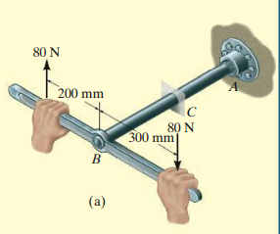
- A solid steel shaft $AB$ is to be used to transmit $3.5 kW$ from the motor $M$. If the shaft rotates at $175 rpm$ and the allowable shear stress in steel is $65 M Pa$, determine the required diameter of the shaft. | 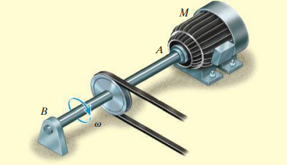
- A hollow shaft and a solid shaft made of the same material have the same length and same outer radius $r$. The inner radius of the hollow shaft is $0.6r$. Assuming that both the shafts are subjected to the same torque, compare the maximum shear stresses developed in the shafts. Also compare the weights of the two shafts and their angles of twist.
- A hollow circular shaft has outer diameter of $100 mm$ and inside diameter of 80 mm. If the shaft is subjected to a torque $T=12 kN.m$, what are the maximum tensile, compressive, and shear stresses?
- A solid circular shaft of steel ($G=80 MPa)$with length $L=3.5m$and diameter $d=120mm$is subjected to pure torsion by a torque $T.$ How much strain energy is stored in the bar when the maximum shear stress is $τ_{max}=60 MPa$?

References
- Mechanics of Materials, 2/e, J. M. Gere & S. P.Timoshenko, CBS Publishers.
- Mechanics of Materials, 6/e, F.P. Beer & E. R. Johnston, McGraw Hill
- Engineering Mechanics of Solids, 2/e, E. P. Popov, Pearson Education Asia.
- Mechanics of Materials, 9/e, R. C. Hibbeler, Prentice Hall.

